2023 Function Dates

2023 Function Dates | Venues | Speaker
15 February 2023  Induction Program 50  Graduation Program 47 | Amadeus  7/180 Thomas St  Haymarket | Justin Wastnage  CEO & Founder  Vloggi | 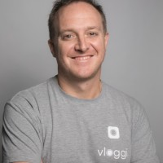
26 April 2023  Induction Program 51  Graduation Program 48 | Radisson Blu  Sydney  27 O’Connell St  Sydney | Tony Archbold  Senior Director of Sales & Marketing APAC  Crystal Cruises | 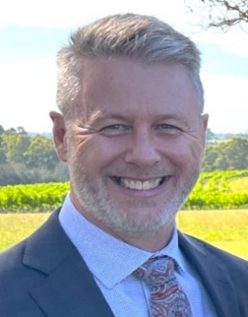
21 June 2023  Induction Program 52  Graduation Program 49 | Sabre  20/133 Castlereagh Street  Sydney  (Limited to 40-45) | Laura Ruffles  COO  CTM | 
30 August 2023  Induction Program 53  Graduation Program 50 | CoverMore  Zurich  North Sydney | Bruce Piper  MD  Travel Daily  TBC | 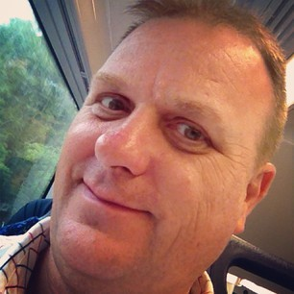
1 November 2023  Induction Program 54  Graduation Program 51 | TTC  35 Grafton Street  Bondi Junction | Astrid Richardson  General Manager - Independent Division of Flight Centre Travel Group | 

